PROJECT REPORT · DATA ANALYTICS
Lichess Chess Analytics
First-move advantage, empirical Elo calibration, opening performance and pre-game outcome prediction
Project metadata
Project title | Lichess Chess Analytics
Dataset | games.csv — 20,058 raw games (Aug 2013 – Sep 2017) → 19,113 unique games after audit
Primary objective | Determine which factors genuinely predict a game's outcome before move 1, and benchmark them against classical chess theory
Technology stack | Python 3.12 · pandas · NumPy · SciPy · scikit-learn · Matplotlib · Seaborn
Repository alignment | games.csv · AnaySinha_LichessChessAnalytics.ipynb · README.md · requirements.txt · report.docx
Report date | September 2026

1 Executive Summary
This report documents an end-to-end exploratory and predictive analysis of **19,113 unique online chess games* played on Lichess. It asks a deliberately narrow question: before the first move is played*, what carries real information about who will win? The answer is short — the rating gap between the players carries almost all of the signal. First-move advantage is real but small, ratings behave more like a “flatter” Elo scale than theory predicts, and neither opening choice nor game speed adds measurable predictive lift.
Metric | Key result | Takeaway
White advantage | 52.4% of decisive games (95% CI 51.6%–53.1%) | Significant at p ≈ 1.5×10⁻¹⁰; positive in every skill bracket and time-control bin
Empirical Elo steepness (k) | k = 0.64 (95% CI 0.61–0.67) | Ratings are flatter than textbook Elo (k = 1); upsets are more frequent
White advantage in Elo points | ≈ 22 rating points (CI 13–30) | Independently confirmed by logistic regression (implied ≈ 22 points)
Game resolution | 56% resign · 31% mate · 8% timeout · 4% draw | Timeouts triple in fast games: 12.3% (<10 min) vs 4.0% (25+ min)
Opening residuals | English +4.5 pp, Bishop’s +6.4 pp; 1.e3 −8.9 pp | Most major lines track rating expectations within ±2 pp
Outcome prediction | 65.1% accuracy · 0.718 ROC-AUC | Rating gap alone; more features add no measurable gain

Statistical baselines
The naïve baseline — always predicting the majority class (White wins) — scores 52.37% accuracy, 0.500 ROC-AUC and 0.6920 log-loss in 5-fold cross-validation. Every reported model gain should be read against these numbers: a rating-gap-only logistic regression lifts accuracy by roughly 12.8 percentage points and AUC by 0.218, whereas all subsequent feature additions move accuracy by less than 0.3 points — well inside the fold-to-fold standard deviation of about 0.8–0.9 points.

Core takeaways
- Skill dominates opening theory. A single number — the rating difference — explains virtually all predictable variation; opening family, first move and pace are second-order effects.
- The first-move edge is real but modest (≈ 2.4 pp above parity), equivalent to about 22 Elo points, and cannot be distinguished between skill tiers or time controls.
- Data quality matters: 4.7% of raw rows were duplicates and 43% of clock timestamps were degenerate, so move counts — not clocks — measure game length.

2 Data Architecture & Forensic Data Audit
The raw file contains 20,058 rows and 16 columns: game identity and timing (id, created_at, last_move_at), format (rated, increment_code), players (white_id, white_rating, black_id, black_rating), outcome (winner, victory_status, turns), and move-level information (moves, opening_eco, opening_name, opening_ply). Before any statistics were computed, seven structural checks were run to decide what could be trusted.
Structural check | Finding | Decision
1. Missing values | 0 cells | None required
2. Duplicate game IDs | 945 rows (4.7%) | Drop; keep first occurrence
3. True duplicates? | 945 rows identical once timestamps are ignored | Yes — same games re-crawled; safe to deduplicate
4. Start time = last-move time | 43% of games | Do not use clock duration; use move count
5. winner = draw but status ≠ draw | 44 rows | Trust winner (timeouts vs insufficient material)
6. turns = number of moves listed | 100% match | turns counts half-moves (plies)
7. Fastest time control | ≈ 7.7 min estimated; only 4 Blitz, 0 Bullet | Lichess speed names do not fit; bin by estimated duration

Deduplication result
945 duplicate records (4.7%) were removed, leaving 19,113 unique matches. Every duplicate was byte-identical on all fields other than the two timestamps, confirming a re-crawl artefact rather than distinct games. The cleaned sample spans Aug 2013 to Sep 2017, is heavily weighted to 2017 (13,088 games, 68%), and contains 15,467 rated and 3,646 casual games. Player ratings run from 784 to 2,723.

Duration cleaning and time-control binning
Because 43% of rows have identical start and end timestamps, clock duration was discarded. Game length is standardised to full moves = ⌈turns / 2⌉. For pace, increment_code was parsed into an estimated duration in seconds; the fastest game is ≈ 7.7 minutes, so Lichess’ Bullet and Blitz labels are unusable. Games were instead grouped into four bins: <10 min (2,060), 10–15 min (10,174), 15–25 min (4,019) and 25+ min (2,860). The dominant format is 10+0 (7,356 games).
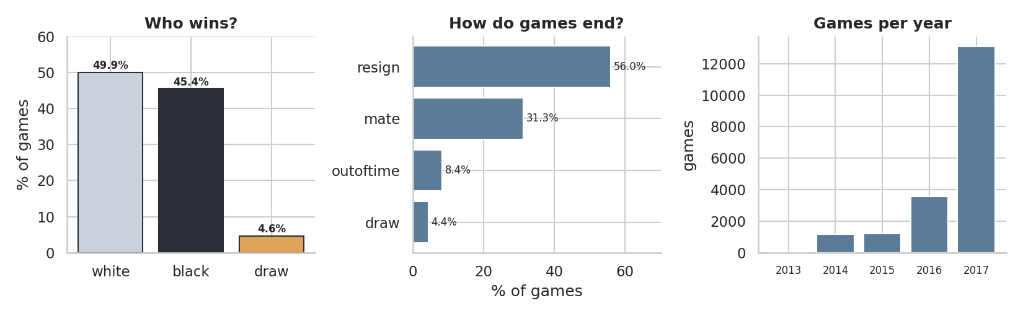
Figure 1. Outcome mix, termination mix and yearly volume of the cleaned sample.

3 Feature Engineering & Mathematical Framework
All derived variables are computed from the deduplicated data. Only features knowable before move 1 are eligible as model inputs; post-game fields such as turns and victory_status are used for description only.
Feature | Definition | Role / note
est_secs | 60 × base_minutes + 40 × increment_seconds | Lichess estimated duration (base plus 40 moves of increment); parsed by regex (\d+)\+(\d+)
time_class | bins of est_secs: ≤599 · 600–899 · 900–1499 · ≥1500 s | <10 min, 10–15 min, 15–25 min, 25+ min
rating_diff | Δ = white_rating − black_rating | Primary predictor; mean 7.3, median 3, SD 247
avg_rating | (white_rating + black_rating) / 2 | Skill tier: <1200, 1200–1499, 1500–1799, 1800–2099, 2100+
white_score | 1 if White wins · 0.5 draw · 0 Black wins | Outcome scale used for Elo calibration
elo_expected | 1 / (1 + 10^(−Δ / 400)) | Textbook Elo expectation (k = 1, no colour bonus)
elo_expected_adj | 1 / (1 + 10^(−(k·Δ + c) / 400)) | Fitted expectation (Section 5); benchmark for opening residuals
full_moves | ⌈ turns / 2 ⌉ | Game length in full moves

Core probability model
E_{W}(Δ) = 1 / ( 1 + 10^{−(k·Δ + c) / 400} )
Loss(k, c) = −(1/N) Σ [ s_{i} ln E_{i} + (1 − s_{i}) ln(1 − E_{i}) ] White bonus = c / k
Here s is white_score, k is the empirical steepness of the rating scale, and c is the colour offset expressed in transformed rating units. Dividing c by k converts the offset back into ordinary rating points.

Opening regex hierarchy
Lichess’ opening_name strings mix a family with a variation (e.g. “Sicilian Defense: Bowdler Attack” or “… | Smith-Morra Gambit”). A two-level hierarchy is extracted:
- Level 1 — `opening_family`: split on the regex [:|], keep the first token and strip whitespace. This collapses 1,477 distinct opening names into 174 families, of which 23 have at least 200 games.
- Level 2 — variation: the remainder after the delimiter, retained in the data but too sparse for inference.
- `first_move`: first token of moves. For modelling, the 25 most common families and 4 most common first moves are kept (e4, d4, c4, Nf3) and the rest are pooled as “Other”.

Leakage rule. Allowed inputs: rating_diff, avg_rating, log(1 + est_secs), time_class, game_type, opening_family, first_move. Excluded outright: turns, full_moves, victory_status, moves beyond move 1, and timestamps.

4 Empirical Evaluation of First-Move Advantage
Draws blur the question “does White have an edge?”, so this section uses only the 18,225 decisive games. White won 9,545 of them: 52.37% (95% Wilson CI 51.65%–53.10%). A two-sided exact binomial test against 50% gives p ≈ 1.5×10⁻¹⁰. Intervals throughout use the Wilson score method, which is well behaved for proportions near 50% and for small subgroups:
p̃ = ( p̂ + z²/2n ) / ( 1 + z²/n ) CI = p̃ ± [ z / (1 + z²/n) ] · √( p̂(1 − p̂)/n + z²/4n² ) z = 1.96

Segment | Decisive n | White wins | White share | 95% Wilson CI | p (vs 50%)
Skill: <1200 | 1,054 | 560 | 53.1% | 50.1% – 56.1% | 0.045
Skill: 1200–1499 | 5,968 | 3,166 | 53.0% | 51.8% – 54.3% | <0.001
Skill: 1500–1799 | 7,196 | 3,762 | 52.3% | 51.1% – 53.4% | <0.001
Skill: 1800–2099 | 3,386 | 1,734 | 51.2% | 49.5% – 52.9% | 0.164
Skill: 2100+ | 621 | 323 | 52.0% | 48.1% – 55.9% | 0.336
Pace: <10 min | 1,971 | 1,045 | 53.0% | 50.8% – 55.2% | 0.008
Pace: 10–15 min | 9,762 | 5,055 | 51.8% | 50.8% – 52.8% | <0.001
Pace: 15–25 min | 3,810 | 2,010 | 52.8% | 51.2% – 54.3% | <0.001
Pace: 25+ min | 2,682 | 1,435 | 53.5% | 51.6% – 55.4% | <0.001
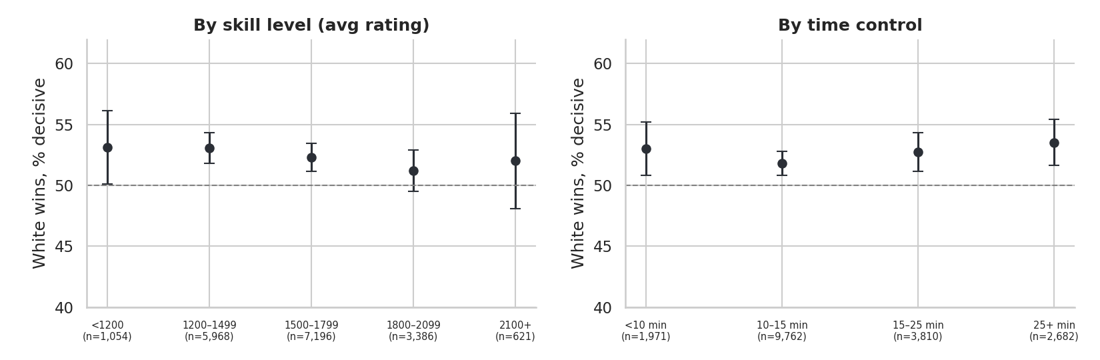
Figure 2. White’s share of decisive games with 95% Wilson intervals, by skill bracket and time control.
Interpretation. All nine point estimates lie above 50%, ranging from 51.2% to 53.5%. The interval excludes parity in the three lower skill brackets and in all four time-control bins. For the 1800–2099 and 2100+ brackets the intervals include 50%, but they also overlap heavily with every other bracket, and the 2100+ group has only 621 decisive games. The data therefore support a modest, broadly uniform White advantage; they do not show that it shrinks at high ratings.

5 Rating Differentials & Empirical Elo Calibration
Textbook Elo says a player rated Δ points higher scores 1 / (1 + 10^(−Δ/400)). To test this on Lichess data, the two-parameter curve from Section 3 was fitted to all 19,113 games (draws scored 0.5) by minimising log-loss with Nelder–Mead from the start point (c, k) = (15, 0.8). Uncertainty comes from 200 bootstrap resamples (seed 42).
Parameter | Estimate | 95% bootstrap CI | Reading
Steepness k | 0.64 | 0.61 – 0.67 | Textbook value is 1.00
Colour offset c (log-loss scale) | 13.8 | — | Shift in transformed units
White bonus = c / k | 21.7 points | 12.5 – 30.5 | ≈ 22 rating points
Logistic cross-check: odds per +100 | × 1.47 | — | Implied bonus ≈ 22 points

With k = 0.64, a 100-point rating gap behaves like a ≈ 64-point gap in the textbook formula, so the stronger player wins less often than nominal ratings imply. The confidence interval excludes 1.0 by a wide margin. Two independent routes — the custom loss minimisation and a plain logistic regression of White’s win on rating difference — agree that White’s colour is worth about 22 rating points.
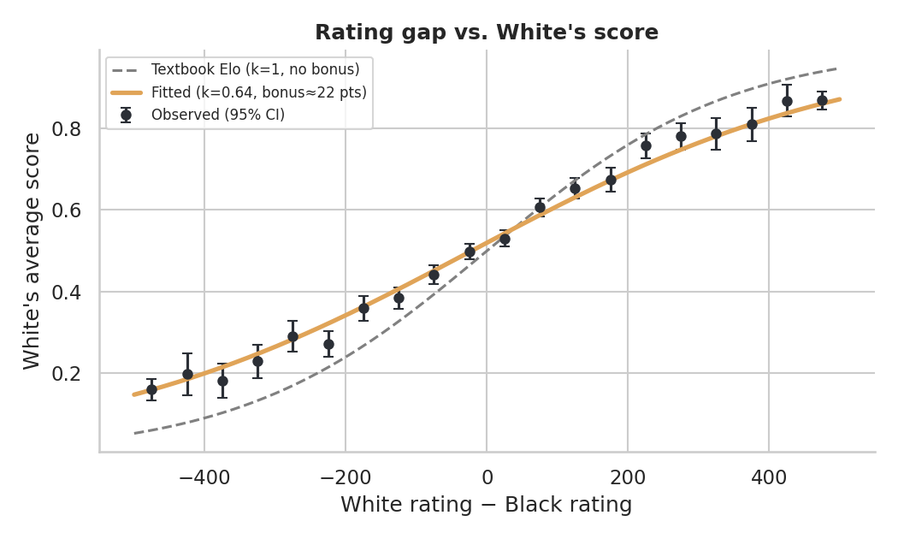
Figure 3. Binned observed score versus rating gap, with textbook Elo (dashed) and the fitted curve.

How often does the favourite win?
Rating-gap threshold | Decisive games | Higher-rated wins | Reference
Any gap | 18,225 | 65.2% | vs 50% for a coin toss
|Δ| ≥ 100 | 10,007 | 73.9% | —
|Δ| ≥ 200 | 5,800 | 80.3% | —
|Δ| ≥ 400 | 1,953 | 86.1% | Textbook expectation ≈ 91%

The favourite wins about two games in three overall and nearly nine in ten once the gap reaches 400 points, but even large gaps leave a substantial upset rate — consistent with the flatter fitted scale.

6 Victory Status & Match Termination Dynamics
Across the cleaned sample, games end by resignation (56.0%), checkmate (31.3%), time forfeit (8.4%) or draw (4.4%). Resignation is by far the dominant ending: more than half of all games are decided by a player conceding, not by a completed mate.
Segment | Games | Mate % | Resign % | Timeout % | Draw % | Median moves
<10 min | 2,060 | 31.4 | 52.3 | 12.3 | 4.0 | 29
10–15 min | 10,174 | 31.6 | 55.2 | 9.5 | 3.7 | 28
15–25 min | 4,019 | 31.6 | 56.6 | 6.6 | 5.2 | 28
25+ min | 2,860 | 29.5 | 60.3 | 4.0 | 6.2 | 26
Casual | 3,646 | 30.0 | 56.5 | 8.1 | 5.5 | 25
Rated | 15,467 | 31.6 | 55.8 | 8.4 | 4.2 | 29
All games | 19,113 | 31.3 | 56.0 | 8.4 | 4.4 | 28
Draw share here is based on victory_status; a further 44 games are recorded as draws by winner alone (timeouts against insufficient material), lifting the result-based draw rate to 4.6%.
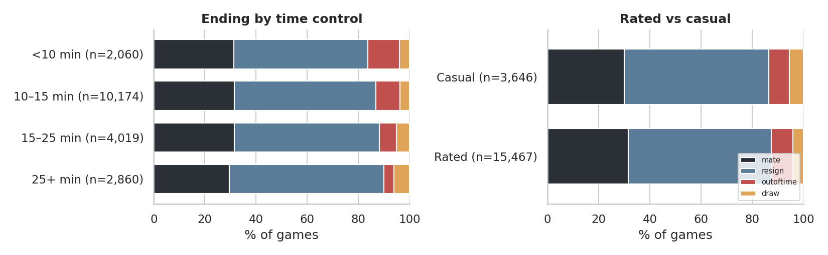
Figure 4. Termination mix by pacing tier (left) and by rated versus casual status (right).

Pacing tiers
Speed reshapes how games finish. Timeouts fall monotonically from 12.3% in the fastest tier to 4.0% in the slowest — a threefold difference — while resignations climb from 52.3% to 60.3% and draws from 4.0% to 6.2%. Checkmate frequency is almost flat (≈ 30–32%) except in the slowest tier (29.5%), where players are more willing to concede a lost position than play it out.

Game formats
Rated and casual games end in very similar ways. Rated games run longer (median 29 vs 25 full moves) and draw slightly less often (4.2% vs 5.5%), consistent with rating points raising the stakes of each decision.

7 Opening Performance & Strength-Adjusted Residuals
Raw opening win rates mostly reflect who plays them: a 1500-rated player choosing an opening does not make it 1500-strength. To isolate the opening itself, each game’s residual is computed against the fitted, colour-adjusted expectation:
Residual = white_score − elo_expected_adj 95% CI = 1.96 · SD(residual) / √n
Families with at least 200 games are retained (23 families); the 15 most-played cover 59.8% of all games.
Opening family | Games | Share | Avg rating | White score | Resid. (pp) | ±95% CI | Sig.
Sicilian Defense | 2,473 | 12.9% | 1,674 | 0.480 | −1.6 | ±1.8 | —
French Defense | 1,258 | 6.6% | 1,628 | 0.515 | −0.7 | ±2.5 | —
Queen's Pawn Game | 1,012 | 5.3% | 1,596 | 0.493 | −2.3 | ±2.8 | —
Italian Game | 926 | 4.8% | 1,588 | 0.515 | −1.6 | ±2.9 | —
King's Pawn Game | 871 | 4.6% | 1,405 | 0.505 | −1.0 | ±3.0 | —
Ruy Lopez | 812 | 4.2% | 1,634 | 0.550 | +1.4 | ±3.1 | —
English Opening | 699 | 3.7% | 1,626 | 0.572 | +4.5 | ±3.5 | Yes
Scandinavian Defense | 688 | 3.6% | 1,533 | 0.517 | −0.6 | ±3.4 | —
Caro-Kann Defense | 559 | 2.9% | 1,667 | 0.520 | +0.3 | ±3.7 | —
Scotch Game | 441 | 2.3% | 1,582 | 0.559 | +1.9 | ±4.3 | —
Queen's Gambit Declined | 377 | 2.0% | 1,699 | 0.556 | +1.0 | ±4.6 | —
Four Knights Game | 344 | 1.8% | 1,510 | 0.542 | +3.9 | ±4.8 | —
Van't Kruijs Opening | 342 | 1.8% | 1,387 | 0.364 | −9.1 | ±4.4 | Yes
Indian Game | 312 | 1.6% | 1,694 | 0.420 | −6.8 | ±4.7 | Yes
Bishop's Opening | 310 | 1.6% | 1,515 | 0.606 | +6.4 | ±4.8 | Yes
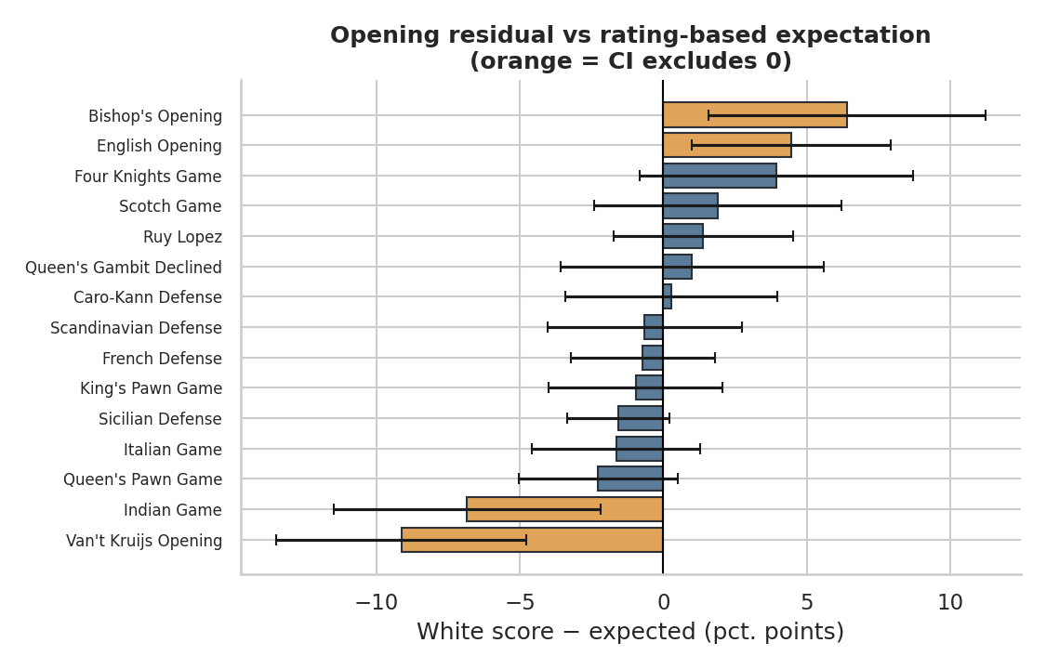
Figure 5. Strength-adjusted residuals for the 15 most-played opening families (orange = CI excludes zero).
Reading the results. Eleven of fifteen families sit within their noise band. English Opening (+4.5 pp) and Bishop’s Opening (+6.4 pp) overperform; Indian Game (−6.8 pp) and Van’t Kruijs Opening, 1.e3 (−9.1 pp) underperform. By first move, 1.e3 is the outlier at −8.9 pp (n = 386), while 1.e4 (+0.4 pp) and 1.d4 (−0.5 pp) are essentially at par. At a 5% threshold about 0.75 false positives are expected among 15 tests, so the four flags are probably genuine but individually modest evidence.

8 Game Length Dynamics
Game length is measured in full moves. The overall median is 28 full moves, and 8.8% of games are over within 10 full moves — of those, 70% are resignations and 9% timeouts, i.e. abandonment, not tactics, explains most very short games.
Termination | Games | Mean | Median | IQR (25–75%) | Max
Resignation | 10,695 | 27.2 | 25 | 17 – 35 | 109
Checkmate | 5,974 | 33.0 | 30 | 21 – 42 | 111
Time forfeit | 1,598 | 36.7 | 36 | 24 – 48 | 175
Draw | 846 | 42.6 | 44 | 24 – 58 | 130
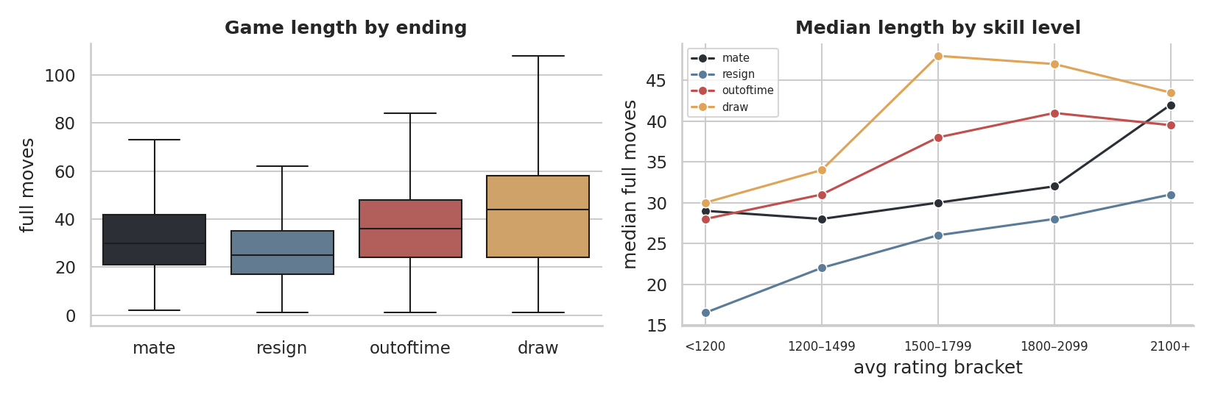
Figure 6. Full-move distribution by termination type (left) and median length by skill bracket (right).
Median full moves | Resignation | Checkmate | Time forfeit | Draw
Avg rating <1200 | 16.5 | 29 | 28 | 30
Avg rating 1200–1499 | 22 | 28 | 31 | 34
Avg rating 1500–1799 | 26 | 30 | 38 | 48
Avg rating 1800–2099 | 28 | 32 | 41 | 47
Avg rating 2100+ | 31 | 42 | 39.5 | 43.5

Interpretation. Ordering is stable: resignations are shortest (median 25), then checkmates (30), time forfeits (36) and draws (44). Stronger players play longer games — resignations lengthen from 16.5 moves below 1200 to 31 at 2100+, and checkmates from 29 to 42 — because they resign later and convert or defend more accurately. Draws and timeouts plateau from 1500 upward.

9 Machine Learning Benchmark
The benchmark predicts whether White wins using only pre-game, leak-free features. It is trained on the 18,225 decisive games (draws removed) and evaluated with stratified 5-fold cross-validation (shuffle, seed 42). Numeric inputs are standardised and categorical inputs one-hot encoded inside each fold’s pipeline, so no preprocessing statistics leak from test folds.
Model | Accuracy | SD | ROC-AUC | SD | Log loss
Baseline: class prior | 52.37% | 0.00% | 0.5000 | 0.0000 | 0.6920
Logistic regression: rating gap only | 65.14% | 0.95% | 0.7177 | 0.0098 | 0.6152
Logistic regression: + skill, speed, rated | 65.20% | 0.85% | 0.7172 | 0.0099 | 0.6155
Logistic regression: + opening & first move | 64.97% | 0.72% | 0.7169 | 0.0093 | 0.6150
Gradient boosting: all features | 64.79% | 0.84% | 0.7156 | 0.0101 | 0.6136
Feature sets: rating-gap only = Δ; + speed/tier/type adds average rating, log(1 + est_secs), time class and rated/casual; + openings adds top-25 opening families and top-4 first moves. All models use random_state 0 or 42 for reproducibility.
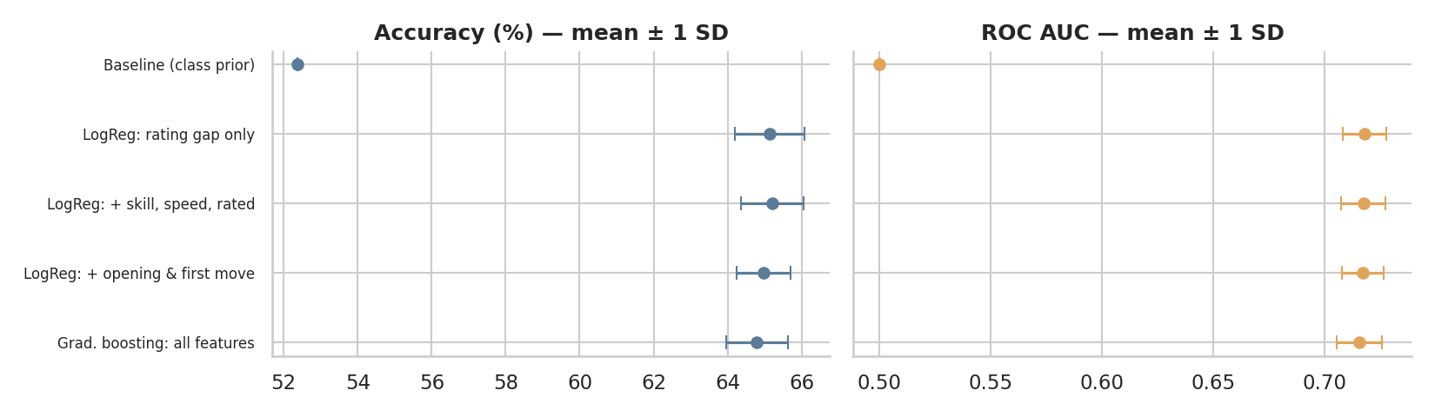
Figure 7. Cross-validated accuracy and ROC-AUC (mean ± 1 SD across folds).

What the benchmark shows
- One feature does the work. Rating gap alone reaches 65.14% accuracy and 0.7177 AUC, a 12.8-point accuracy gain over the class prior.
- Extra features do not help. Accuracy across the three logistic models varies by 0.23 points and AUC by 0.0008 — far smaller than the fold-level SD (≈ 0.7–1.0 points). The non-linear gradient-boosting model, with the lowest log-loss (0.6136), improves it by only 0.0016 versus the rating-only model.
- Interpretable summary: each +100 rating points multiplies White’s odds of winning by × 1.47, with an implied White bonus of ≈ 22 points, matching the Section 5 calibration.

10 Methodological Takeaways & Roadmap

Key methodological takeaways
- Audit first. Deduplication removed 4.7% of rows and the zero-duration finding changed how game length is defined; both would silently bias a naïve analysis.
- Calibrate before comparing. Opening residuals are meaningful only because they are measured against a fitted, colour-adjusted expectation instead of a raw 50% or textbook Elo baseline.
- Report uncertainty. Wilson and bootstrap intervals prevent over-reading small subgroups such as the 2100+ bracket.
- Guard against leakage. Excluding turns and victory_status keeps the 65% accuracy honest as a genuine pre-game estimate.

Limitations
- Sampling frame: a single crawl, 68% of it from 2017, with no Bullet and almost no Blitz games — results may not generalise to faster formats or to current Lichess.
- Non-independence: roughly 15,600 distinct players appear across 38,200 player slots, so games by the same player are correlated and intervals are likely somewhat optimistic.
- Outcome scope: prediction excludes draws (4.6%); opening residuals reflect player self-selection into openings that a rating-only adjustment cannot fully remove; and 15 opening tests invite occasional false positives.

Roadmap
Initiative | Deliverable | Expected value
Engine evaluation integration | Run Stockfish on positions after a fixed number of plies; add centipawn evaluation and blunder counts per game | Separates intrinsic opening quality from player skill; measures the true size of the first-move edge
Move-text feature extraction | Parse moves for early captures, castling timing, checks, piece development and opening_ply | Tests whether early-game structure adds signal beyond rating gap, still leak-free when limited to opening moves
Player-level modelling | Use white_id / black_id for grouped cross-validation and random-effects or rating-uncertainty terms | Corrects non-independence and gives honest intervals
Dashboard deployment | Streamlit or Dash app with bracket, pace and opening filters, live residual charts and a win-probability calculator | Makes the analysis explorable and shareable beyond the notebook
Broader data refresh | Ingest recent Lichess exports including Bullet and Blitz; re-fit k and the White bonus per speed | Checks whether the flatter scale and 22-point bonus persist across formats

Bottom line. Before the first move, chess outcomes on Lichess are governed overwhelmingly by the rating gap, with a modest and stable ≈ 22-point advantage for White. The most promising route to better predictions is not more pre-game metadata but richer in-game information, such as engine evaluations and move-level features.

